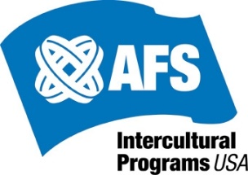

Dear Friends,
AFS USA, an intercultural educational program, is looking for a new host family for Make from Thailand. Make is currently attending Benson Polytech School in Portland. He is doing well in school and he would like to stay in Benson Polytech High. He will need a new family by end of January.

We are looking for a family to host him from now until late June. If you would like more information, please go to: https://www.afsusa.org/host-family/get-started/ and give me your contact, I will call you as soon as I get your information.

Meet Make:
Wichayut, nicknamed "Make" which means "cloud" in Thai, he loves movies, music and reading, and hangs out in bookstores in his spare time. He attended a public boarding school not far from his town in Thailand, and now he is attending Benson Polytech in SE Portland. He helps with housework and some cooking at his host family’s home and helped out back home on the weekends with his natural Mother. Make is a top student in a Math/Science program, Make plans a career in business. He is doing very well at Benson Polytech High currently. To stay fit, he swims, runs and enjoys working out. He will be joining the Benson Tennis team in the Spring. He is a quiet person and he is open-minded and loves to listen to conversations. He enjoys being with his newly made friends at Benson and hanging around the local AFS hosted international students. And, he enjoys time alone as well. He is grateful and happy to be hosted in our Portland team and is a very sweet person. He loves to eat and enjoys any food put in front of him.

If you cannot host, please pass this note along to others. Thank you for helping to get the word out that we are looking for a new family for Make from Thailand.
Your help is appreciated.
Shaun Sullens
503-894-0367

