THE AP EXAM REGISTRATION HAS MOVED TO FALL.
The deadline is now November 1st, 2019.
Fee waiver/reduction:
Student requests Form from AP Coordinator. Return completed form by October 15th.
Credit/Debit Card: family pays deposit online
Cash: Student pays deposit to school’s bookkeeper
Student/family receive confirmation email with a new JOIN CODE for exam. The email contains a link to join the EXAM section of AP course(s) at myap.collegeboard.org.
AP Student joins class section with online code given by AP teacher.

Check:
Mail deposit check to APTS, postmarked by October 15th.
School gives student the fee waiver code.
Family enters waiver code online.
AP Testing Service verifies the code.
Begin the registration process at www.APTestService.com/pps

Complete your College Board Profile using your PERSONAL Email Account.
Exam Registration Complete!

PLEASE NOTE:
- You MUST be registered by November 1, 2019 to take the exam.
- The $40 per exam deposit is non-refundable after November 1, 2019.
- Families will receive monthly balance invoice reminders. Balance due March 30, 2020.
- If you have a 504 or IEP and need an accommodation, see your counselor as soon as possible.
- PLEASE READ ALL EMAILS FROM AP TESTING SERVICE!
More information available at www.pps.net/APTesting.
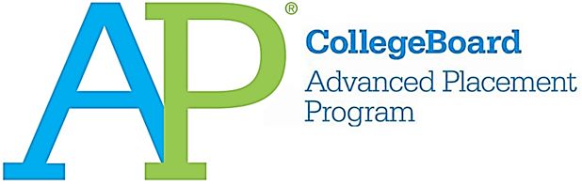

It is time to register for AP Exams!
Registration runs from October 1 to November 1.

  - You MUST register in order to take an exam. November 1st is the LAST day to register.
  - No walk-ins will be permitted. You must have registered for an exam to take one.
  - If planning to take two exams scheduled for the same day or time, register online as normal. In February, you will receive further information regarding which exam you will take on the scheduled date and which you will take on a different scheduled date.
  - The full cost of each exam is $94. AP Research and Seminar are $142 each.
  - Parent or Guardian permission is required.
  - Register online at www.APTestService.com/pps.

Exams will be administered again at the Portland Expo Center in North Portland.
AP Japanese and Chinese will take place at the BESC at 501 N. Dixon St.

- Week 1. May 4th – May 8th, 2020
- Week 2. May 11th – May 15th, 2020

For more info, visit www.pps.net/APTesting, apstudent.collegeboard.org or see your school’s AP Testing Coordinator, _________________.

